“GET YOUR MOJO ON”

Fall Fishing Tactics
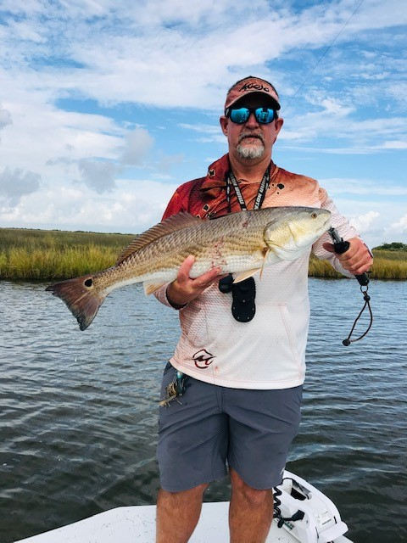 | Captain Steve Fleming is a USCG licensed & insured Charter Boat Capatian and professional tournament angler fishing out of Game-On Charters Lodge located in Dularge, Lousiana, minutes south of Houma. Captain Steve specializes in sight casting to redfish with artifical lures.  You can look him up on face book at Game-On Charters, or visit his web site.  www.game-oncharters.com

It won’t be long and the dog days of the summer will be fading away, and we will soon experience shorter and cooler days as the fall weather sets in. The fall and winter offers some of the best inshore fishing anglers can experience if they are willing to bare the elements. This month, Captain Steve Fleming will discuss fall fishing tactics that will help anglers increase their chances of bagging their limits this fall.

Fall Weather also means Duck Hunting Season is soon to open, and with all the private property that we enjoy fishing throughout the summer, will soon be off limits. Duck hunters only have 3 to 4 months out of the year to enjoy their beloved passion, and I feel it is important that we respect their limited time available for hunting, and navigate clear of the duck hunters. Respect their boundaries, as you would expect another fisherman to respect your boundaries while on fish.

Although we have recently experienced some of the highest tides (Non-Storm Surge) that I can remember, we will soon experience cooler weather from the North, and this will mean lower tides, and strong Northerly winds. These lower tides and northerly winds mean that redfish will be abandoning the low water marsh ponds and will be stacking up along the shorelines of the larger and deeper lakes. Lucky anglers in pursuit of redfish should be concentrating on the leeward shorelines, around small trenasse and bayous that are draining the marsh.

As the water temperature begins to drop, and the deep marsh begins to drain, another change in pattern that we can expect, is to begin seeing smaller concentration of bait, such as finfish, crab, and shrimp. Changing your fishing tactics and patterns and keying on the smallest amount of nervous bait and water movement will help you bag your limit every time out. This is especially important as we move into the winter months.

Fishing around and near deep passes and the open water of barrier islands, with strong currents will also pay big dividends to those anglers that are looking to stretch their line with large bull reds. The “Bull Reds” are females, and they typically start spawning in South Louisiana around October & November. The large “Bull Reds” will be moving in from Offshore and begin concentrating in and around barrier islands and deep passes with swift current. During this time, male redfish will start staking out in the surrounding areas in large schools ready to spawn. When the wind allows, anglers should be concentrating around the open water of barrier islands and large passes, and they are certain to increase their chances bagging their limits.

Remember to respect our Duck hunting friends, concentrate on the bayous that are feeding the shorelines of the larger lakes, and expect to key on small amounts of bait and water movement, and when the winds will allow you to fish the open water surrounding barrier islands and deep passes, you will soon understand why fall fishing is so exciting.

Until next time, “Get Your Mojo On” and Tight Lines
Captain Steve Fleming
Mojo Pro Staff

www.Game-Oncharters.com

